



Design Specification

ReadySetResource.com

Contents

5.1 - Data Flow Diagrams 3

5.2 - System Architecture 3

5.3 - Use Case Descriptions 4

5.4 - Use Case Diagrams 5

Initial Use Case Diagram 5

Extended Use Case Diagram 5

5.5 - Activity Diagrams 6

5.6 - Class Diagrams 6

5.7 - Sequence and Communication Diagrams 6

5.8 - State Diagrams 6

5.9 - Normalisation 7

5.10 - Data Model 8

5.11 - Form Layouts 8

5.12 - Object-Relational Mapping 8

5.13 - Class Definition Document 8

5.14 - Data Dictionary 8

5.15 - Conceptual Entity Relationship Diagram 9

Conceptual ERD 10

5.16 - Physical Entity Relationship Diagram 12

5.17 - Screen Layout 14

5.18 - Validation Control Forms 14

5.19 - Event-Handling Forms 14

5.20 - Identifier Lists 14

5.21 - Bibliography 14

5.22 - Software Requirements Spec. Work Log 14

# 5.1 - Data Flow Diagrams

# 5.2 - System Architecture

# 5.3 - Use Case Descriptions

* Where is it?

# 5.4 - Use Case Diagrams

Initial Use Case Diagram

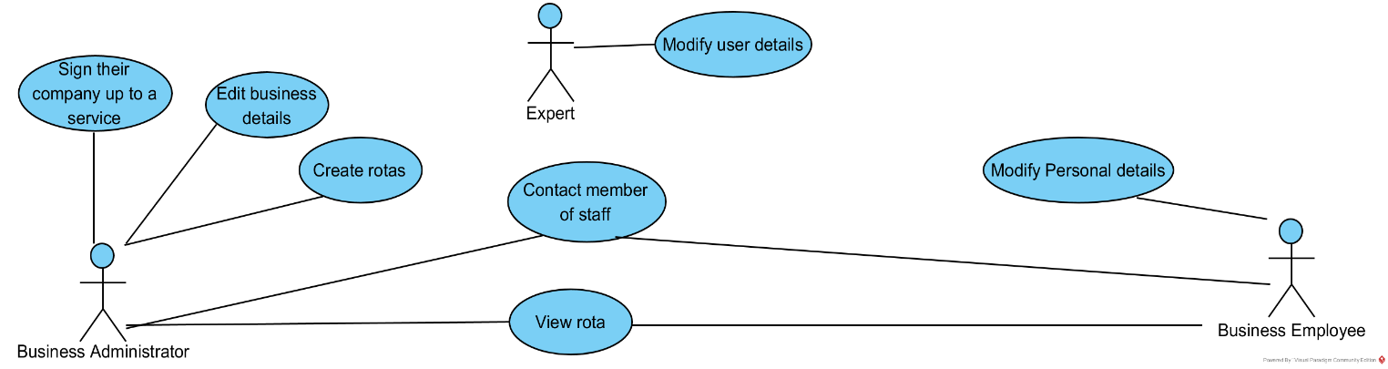

* What about updating rotas?
* Production of reports?

Extended Use Case Diagram

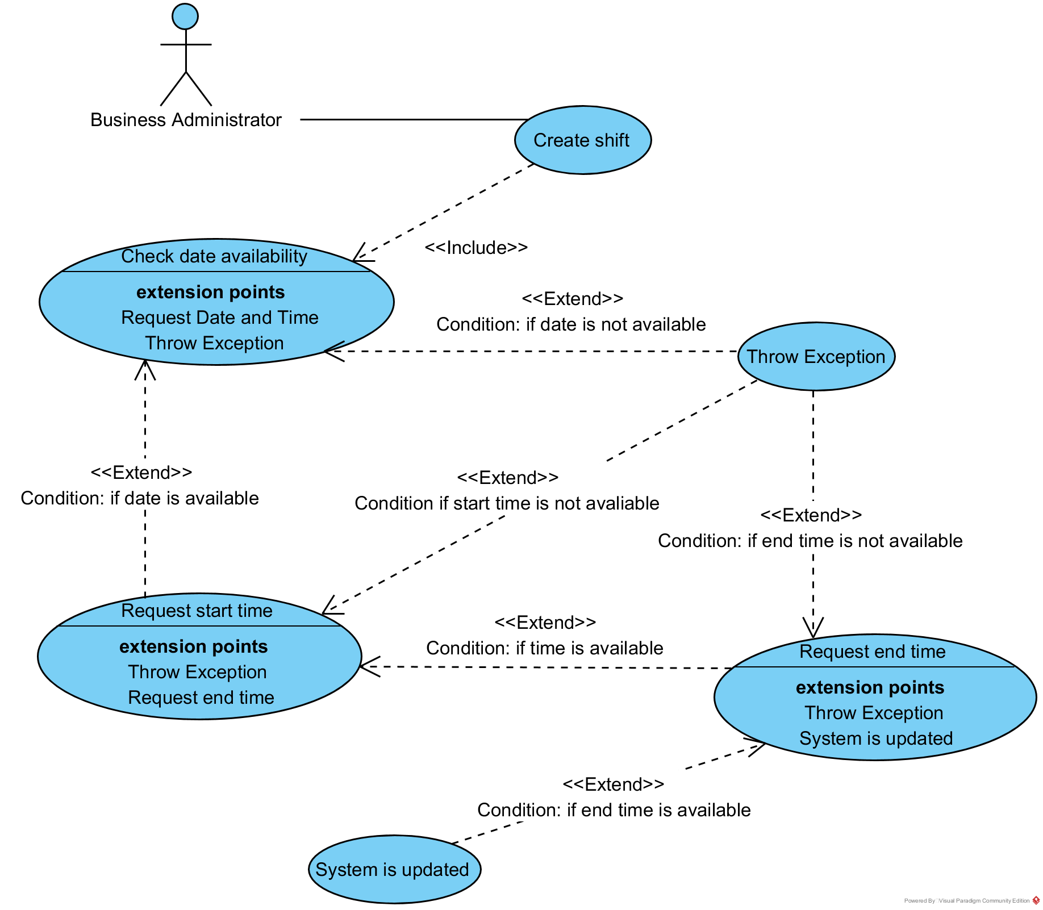

* Does nothing happen after “Throw Exception”?

# 5.5 - Activity Diagram

# 

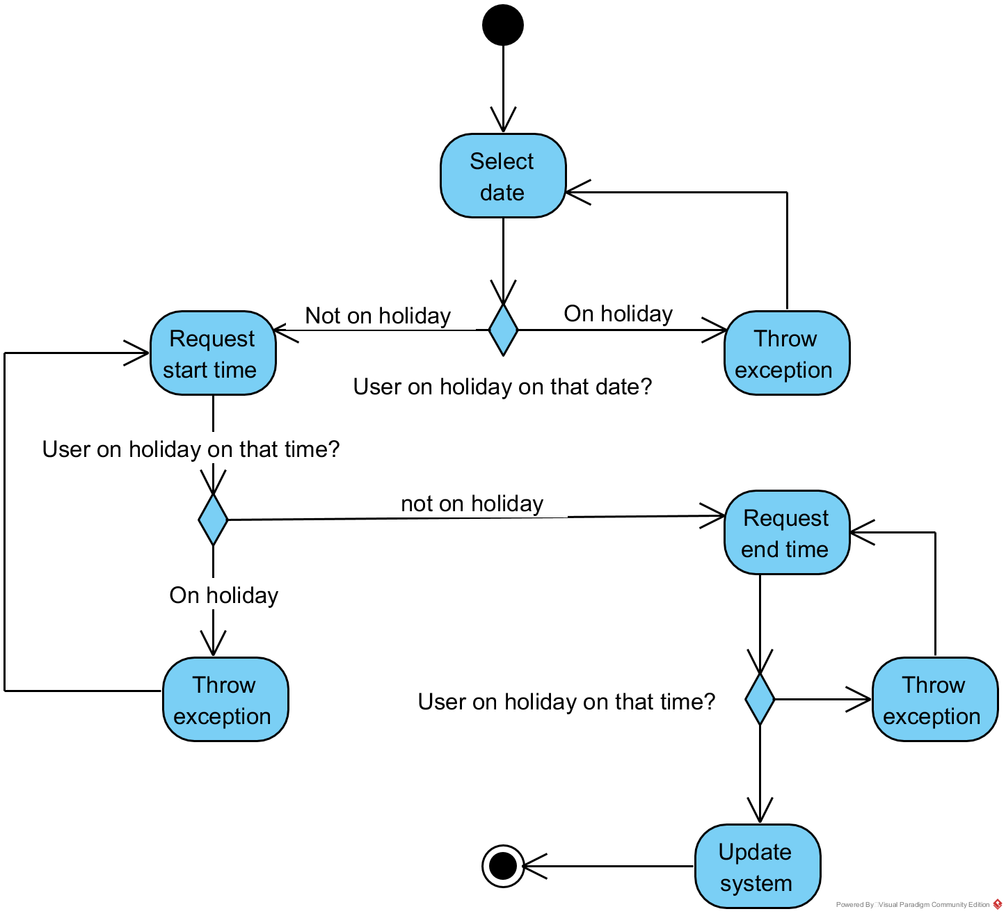

* Where is the creating/producing of the rota?

# 5.6 - Class Diagram

* What have the following classes got to do with creating rotas:
  + Questions/Answers/Cases
  + Ideas/Transactions/Items
* Please talk to Dana and myself about your diagram.

# 5.7 - Sequence and Communication Diagrams

# 5.8 - State Diagrams

# 5.9 - Normalisation

| UNF | 1NF | 2NF | 3NF |
| --- | --- | --- | --- |
| Order Id | Order Id | Order Id | Order Id |
| Order Date | Order Date | Order Date | Order Date |
| Staff Name | Staff Name | Staff Name | Staff Id* |
| Staff Id | Staff Id | Staff Id | Customer Id* |
| Customer Id | Customer Id | Customer Id | Quantity |
| Customer Name | Customer Name | Customer Name |  |
| Street | Street | Street |  |
| Town | Town | Town | Staff Id |
| Postcode | Postcode | Postcode | Staff Name |
| Customer Phone Number | Customer Phone Number | Customer Phone Number |  |
| Product Id |  |  | Customer Id |
| Product Name | Order Id | Order Id | Customer Name |
| Quantity | Product Id | Product Id | Street |
| Product Price | Product Name | Order Total | Town |
| Order Total | Quantity |  | Postcode |
|  | Product Price | Product Id | Customer Phone Number |
|  | Order Total | Product Name |  |
|  |  | Quantity | Product Id |
|  |  | Product Price | Product Name |
|  |  |  | Product Price |
|  |  |  |  |
|  |  |  | Order Id |
|  |  |  | Product Id |
|  |  |  | Order Total |

# 5.10 - Data Model

# 5.11 - Form Layouts

# 5.12 - Object-Relational Mapping

# 5.13 - Class Definition Document

# 5.14 - Data Dictionary

# 5.15 - Initial Entity Relationship Diagram

# 

# None of the above appear in the Class Diagram – Why?

# 5.16 - Extended Entity Relationship Diagram

# 5.17 - Screen Layouts

# 5.18 - Validation Control Forms

# 5.19 - Event-Handling Forms

# 5.20 - Identifier List

Users

| Name | Scope | Description |
| --- | --- | --- |
| Id | Global | Integer(10) - Used as a PK for users |
| Titile | Global |  |
| FirstName | Global |  |
| LastName | Global |  |
| DateOfBirth | Global |  |
| Email | Global |  |
| BUEmail | Global |  |
| ProfilePicLink | Global |  |
| CountryCode | Global |  |
| PhoneNumber | Global |  |
| AddressLine1 | Global |  |
| AddressLine2 | Global |  |
| PostCode | Global |  |
| Town | Global |  |
| Region | Global |  |
| Country | Global |  |
| Blocked | Global |  |
| TimesLoggedIn | Global |  |
| Sex | Global |  |
| NIN | Global |  |
| EmergencyContact | Global |  |
| Raise | Global |  |
| Strikes | Global |  |

Users

| Name | Scope | Description |
| --- | --- | --- |
| Id | Global |  |
| Titile | Global |  |
| FirstName | Global |  |
| LastName | Global |  |
| DateOfBirth | Global |  |
| Email | Global |  |
| BUEmail | Global |  |
| ProfilePicLink | Global |  |
| CountryCode | Global |  |
| PhoneNumber | Global |  |
| AddressLine1 | Global |  |
| AddressLine2 | Global |  |
| PostCode | Global |  |
| Town | Global |  |
| Region | Global |  |
| Country | Global |  |
| Blocked | Global |  |
| TimesLoggedIn | Global |  |
| Sex | Global |  |
| NIN | Global |  |
| EmergencyContact | Global |  |
| Raise | Global |  |
| Strikes | Global |  |

# 5.21 - Bibliography

# 5.22 - Software Requirements Spec. Work Log

| Entry | Description | Person | Date | Mins Spent |
| --- | --- | --- | --- | --- |
| 1 | Formatted the document | Aidan Marshall | 25/11/17 | 6 |
| 2 | Started the Conceptual ERD | Aidan Marshall | 14/11/17 | 68 |
| 3 | Continued the Conceptual ERD | Aidan Marshall | 16/11/17 | 43 |
| 4 | Continued the Conceptual ERD | Aidan Marshall | 19/11/17 | 82 |
| 5 | Continued the Conceptual ERD | Aidan Marshall | 22/11/17 | 122 |
| 6 | Wrote the Conceptual ERD key | Aidan Marshall | 25/11/17 | 32 |
| 7 | Continued the Conceptual ERD | Aidan Marshall | 25/11/17 | 145 |
| 8 | Continued the Conceptual ERD | Aidan Marshall | 26/11/17 | 188 |
| 9 | Finished the Conceptual ERD | Aidan Marshall | 27/11/17 | 328 |
| 10 | Modified the conceptual ERD | Aidan Marshall | 28/11/17 | 120 |
| 11 | Decided to concentrate on critical requirements | Aidan, Graham | 26/3/18 | 12 |
| 12 | Took out ERD descriptions | Aidan Marshall | 26/3/18 | 4 |
| 11 | Created the use case diagrams | Aidan Marshall | 26/3/18 | 62 |
| 12 | Created the class diagram | Aidan Marshall | 26/3/18 | 26 |
| 11 | Created the ERDs | Aidan Marshall | 26/3/18 | 79 |
| 12 | Created the use case descriptions | Aidan Marshall | 26/3/18 | 16 |
| 13 | Created the identifier list | Aidan Marshall | 26/3/18 | 22 |
| 14 |  |  |  |  |
| 1355 | | | | |